Planning makes it easier to manage waste at events. This template provides a structure to consolidate your goals and strategies with your actions and planning requirements for managing waste at your event.

Purpose and overview

This waste action plan template provides guidance to create:

* Event overview
* Waste objectives, targets, and measures of success
* Waste initiatives and strategies
* A list of your events’ needs:
* Waste types and expected material generation
* Infrastructure needs
* Site plan
* Waste disposal, processing and contracting
* Operational checklists:
* Planning the event
* Setting up the event
* During the event
* After the event

Event Overview

|  |  |
| --- | --- |
| Event details | |
| Event: | *e.g. title of event* |
| Location (attach or insert map if possible): | *e.g. venue name, location and description* |
| Time: | *e.g. start and finish time* |
| Date(s) of event: | *e.g. start and finish date* |
| Attendance: | *e.g. 500 people* |
| Attendee awareness of waste issues: |  |
| Organiser(s): | *e.g. lead organisation hosting the event* |
| Other |  |

|  |  |  |  |  |
| --- | --- | --- | --- | --- |
| Contact details | | | | |
| Role in the event | Name | Organisation | Responsibility | Contact number |
| *e.g. Lead Event Manager* |  |  |  |  |
| *e.g. Stallholder* |  |  |  |  |
| *e.g. Volunteer* |  |  |  |  |
| *e.g. Bin monitoring/sorting/clean-up staff* |  |  |  |  |
| *e.g. Contractors* |  |  |  |  |

Goals and targets

### Waste and litter outcomes, Targets and Measureable indicators

* Set objectives and targets to guide strategies and facilitate results to be measured.
* Make targets for several years in the future, then prioritise what can be done now, and what can be done later.
* Make targets ***SMART*** (Specific, Measurable, Achievable, Relevant and Time-bound).

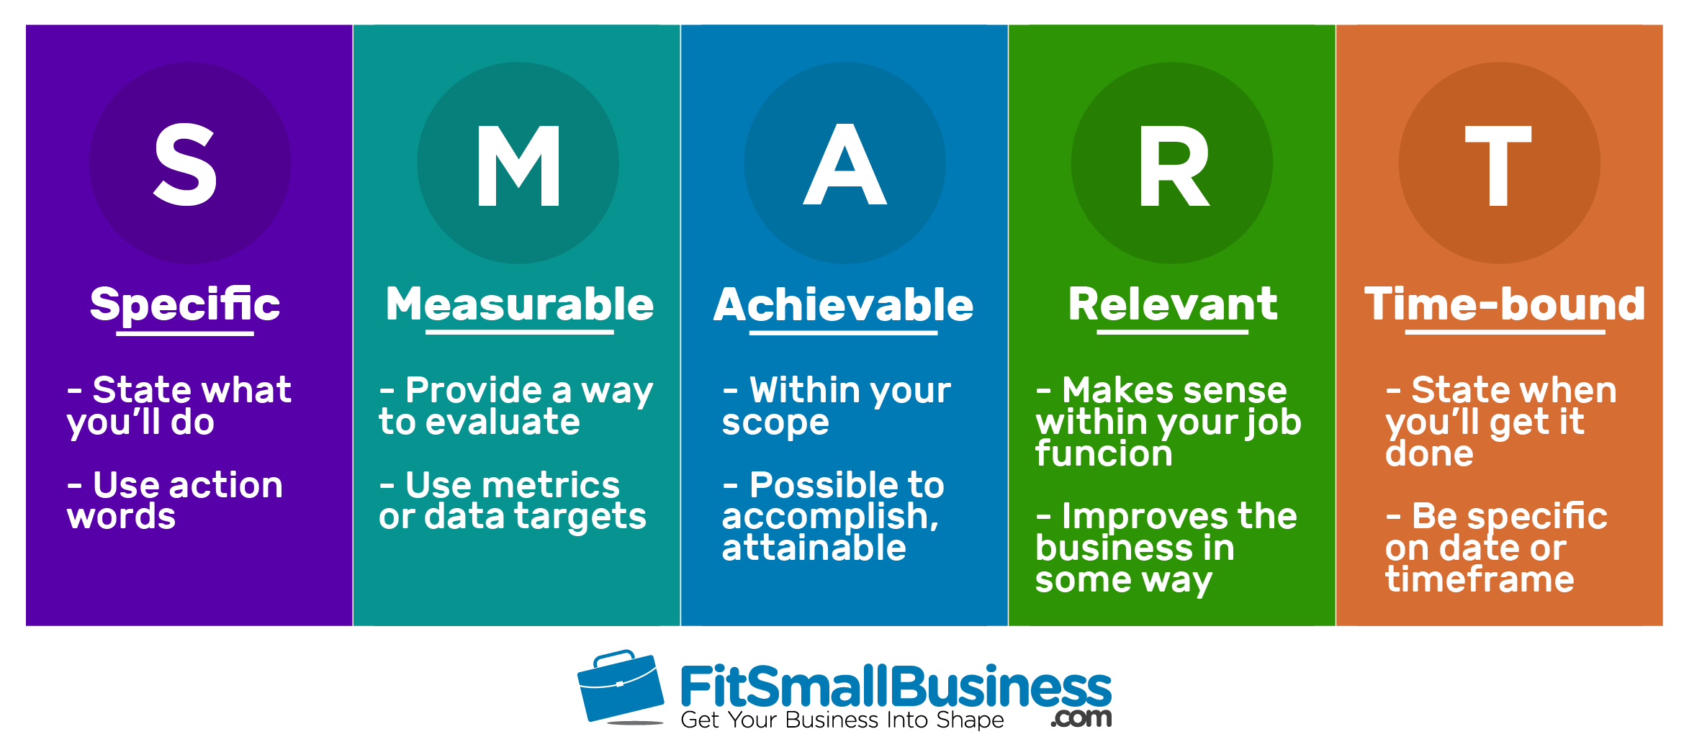

|  |  |  |  |
| --- | --- | --- | --- |
| outcomes | Target | How will you measure success? | Indicators for success |
| e.g. reduced total material use and disposal | e.g. achieve 20% reduction of total material collected, including recycling and landfill, by [year], | *e.g. request disposal and recycling dockets from contractors to compare amounts* | e.g. reduced skips used back of house, reduced collections or reduced recorded volumes |
| e.g. eliminated single use plastics (SUPS) | e.g. achieve an event where no single use plastics are used | *e.g. bin inspection, site inspection or waste audits to identify presence/absence of plastics* | e.g. no stallholder use SUPs, no SUPs are found in bins or on site |
| e.g. reduced the amount of organic material going to landfill | e.g. 90% reduction in the amount of food waste disposed of in the landfill bins during the event in its first year | e.g. conduct a waste audit and/or report end of event waste generation per stream | e.g. audit results show that food waste has been re-directed to the organics waste bin rather than the landfill bin |
| e.g. reduced litter at the event and the adjacent environment | e.g. 75% reduction of litter items throughout the event | e.g. conduct a site litter assessment | e.g. reduced number of litter items found at/after event  *e.g. staff and patron perception of the event is tidy and clean* |
| e.g. reduced contamination in recycling to increase value of process | e.g. achieve a contamination rate of below 2% | e.g. ask contactor to report contamination rates | e.g. reported contamination rate |

### Waste initiatives and strategies

* Outline what actions, both practical initiatives and strategic planning that you can do at the event that will assist to achieve your waste objectives and targets.
* List many actions but deliver them gradually so that the changes can be implemented with the right resources and knowledge.

These can cover:

* Food and beverage stallholders – for example single use plastic ban, compostable/recyclables, sourcing ingredients in bulk containers, portion control.
* Encourage reusable/refillable containers for stallholder commodity use – for example kegs instead of bottles/tins, water stations etc.
* Encourage the use or provision of reusables – cups, glasses or full crockery set.
* Access to water refill stations.
* Consider sustainable building materials.
* Waste separation systems – front and back of house.
* Education initiatives – bin monitoring, signage and communication strategies.

Know your Event

### Estimate Waste types and volumes

* List back and front of house generation points.
* List set up, delivery and post event generation time.

|  |  |  |  |  |
| --- | --- | --- | --- | --- |
| Source | Product type | Material generated | Estimated quantity | When |
| *e.g. coffee van* | *e.g. hot drinks and snacks* | *Cardboard*  *Compostable food packaging*  *Compostable coffee cups* | *240L*  *10L*  *240L* | *During event* |
| *e.g. bar* | *e.g. drinks* | *Compostable cups*  *Recyclable containers*  *Citrus and scraps* | *360L*  *240L*  *120L* | *During event* |
| *e.g. food van* | *e.g. food waste* | *Scraps, leftovers* | *360L* | *During event* |
| *e.g. campsite* | *e.g. food, soft plastics, drinks* | *Scraps*  *Plastic wrap and films*  *Recyclable containers* | *120L*  *360L*  *3m3* | *During event, post event* |
| *e.g. exhibitors* | *e.g., boxes, packaging* | *Cardboard*  *Plastic film*  *Plastic pots* | *3m3*  *360L*  *3m3* | *Set up, during event, post event* |
| *Total/Summary* | *Food*  *Drinks* | *Compostable packaging*  *Food scraps* | *3000L* | *Whole event* |

### List Infrastructure and services Needs

Based on the initial assessment of waste types and material that may be generated at your event, plan what infrastructure is needed. Discuss this with your operational staff, stallholders, and contractors. Consider:

* Your site layout and natural points of bin use as well as servicing access to bins by staff
* Signage needs for front of house and back of house
* Messaging and education.

|  |  |  |  |  |
| --- | --- | --- | --- | --- |
| Type | Existing or required | QuanTity  Number of and capacity | Location | Frequency of servicing/ collection |
| **Front of house** | | | | |
| *e.g. Organics bin* | *e.g. Required* | *e.g. 20 x 240L bins with lids* | *e.g. At the picnic area (refer to site plan)* | *e.g. The bin will be collected and replaced every 2 hours* |
| *e.g. Reusable crockery drop-off* | *e.g. Existing* |  | *e.g. Bar, wash station* | *e.g. The crockery to be collected and cleaned every 30 minutes during peak times* |
| *e.g. Signage* | *e.g. Required* | *20 x organic, 20 x reusable* | *e.g. At all bins* | *e.g. Bin monitoring staff always stationed at hubs* |
| **Back of house** | | | | |
| *e.g. Organics skip* | *e.g. Required* | *e.g. 2 x 3m3 skip* | *e.g. Depot* | *e.g. Removed at the end of the of the event* |
| *e.g. Commercial dish wash station* | *e.g. Existing* | *e.g. 1 x wash station* | *e.g. Community hall* | *e.g. Crockery delivered and collected as required* |

### Site plan

The site plan should provide an overview of the layout for the event and show where all the infrastructure will be located (front of house and back of house), including:

**Waste specific**

* Bins/bin hubs
* Resource recovery yard
* Food/drink stalls
* Waste audit area
* Toilets

Do not forget to include items that will link to the event operations and waste management, including but not exclusive to:

* Event and incident coordination centre/information centre/lost kids/property/first aid posts
* No alcohol areas
* Licensed liquor consumption areas/liquor outlets
* Non-smoking areas – around food stalls etc.
* Entrances & exits ­– emergency access & egress routes
* Main power/water/gas control
* Restricted areas/media/security locations (if bags and eskies will be searched, then allow for confiscated materials)
* Entertainment sites/stage location
* Drinking water sites
* Toilets and toilet blocks – state whether mobile/sanitary waste/sharps containers
* Pedestrian route/congregation areas/seating
* Public telephones
* Drainage pits
* Vehicle access and flow routes/parking/taxi and bus stops
* Picnic/quiet areas
* Firefighting equipment – fire extinguishers, fire blankets, hose reels, hydrants
* Other additional items.

Waste disposal, processing and contractors

This section should outline what will happen to each identified waste stream.

* Research and ask your collection contractors and ensure you know:
* What streams can be separated and recovered (e.g. organics, aluminium, oils, cardboard etc)
* If they can provide front of house bins and/or skips in what sizes
* Charging structure (is it per collection, per weight, per days)
* Consider local opportunities such as community composting, glass collected in specific colours, local community groups who collect containers for cash.
* Make sure you have details, names, and contact details for each collection contractor (who picks it up – commercial or local and when)
* The destination for all material (recycling, composting) and what will happen to the material after processing (if known)
* Ask for records of the weight and volume of collected waste and visual audits/evidence of end destination such as pictures of the skip taken to a facility.

Service cost of waste services

*when comparing options of bin configuration consider all costs

MATERIALS + ON SITE STAFF SERVICING + COLLECTION + PROCESSING + DISPOSAL AT LANDFILL

The Tasmanian Landfill Levy was introduced at $20/t in July 2022 and increased to $40/t in 2024 and $60/t in 2026.

Checklists

### Planning the event

|  |  |  |  |
| --- | --- | --- | --- |
| Task (what) | Description (how) | Responsibility (who) | Completed (when) |
| Establish key messages to promote waste minimisation objectives to all event staff, patrons, and the community | *e.g. waste targets and services outlined in staff/stallholder/contractor introduction letter and briefing session*  *e.g. Refer to the* ***Communication Plan*** | *e.g. Waste / event coordinator* | Timeframe  Yes / No |
| Establish a team (paid or volunteers) for overseeing the implementation of the waste plan during the event and for set-up and pack down |  | *e.g. Waste / event coordinator* | Yes / No |
| Communicate ahead of the event with all stallholders about the waste objectives and processes, for example through emails or briefing sessions |  | *e.g. Waste / event coordinator* | Yes / No |
| Arrange for drop-off and collection of all bin infrastructure and materials required |  | *e.g. Waste / event coordinator* | Yes / No |
| Arrange all personal protective equipment (PPE) for staff / volunteers who are handling waste during and after the event |  | *e.g. Waste / event coordinator* | Yes / No |

### Setting up the event

|  |  |  |
| --- | --- | --- |
| Task | Responsibility | Completed |
| Review the waste action plan with the team prior to setting up the event | *e.g. Waste / event coordinator* | Yes / No |
| Label all bins and stations | *e.g. Waste / event coordinator* | Yes / No |
| Distribute all bins and skips to stations (all bins should be located at stations where more than one waste stream is available) | *e.g. Waste / event coordinator* | Yes / No |
| Install all signage | *e.g. Waste / event coordinator* | Yes / No |
| Monitor stallholders as they set up | *e.g. Waste / event coordinator* | Yes / No |
| Do a final inspection of all signage and bins before event opens | *e.g. Waste / event coordinator* | Yes / No |

### During the event

|  |  |  |
| --- | --- | --- |
| Task | Responsibility | Completed |
| Monitor and collect front of house bins as required | *e.g. Volunteer Waste Officers* | Yes / No |
| Monitor stallholders | *e.g. Volunteer Waste Officers* | Yes / No |
| Monitor used crockery sites (if applicable) and kitchen | *e.g. Volunteer Waste Officers* | Yes / No |
| Monitor amount of waste generated | *e.g. Waste / Event Coordinator* | Yes / No |
| Monitor back of house collection points | *e.g. Volunteer Waste Officers* | Yes / No |
| Conduct surveys of stallholders and patrons | *e.g. Volunteer Waste Officers* | Yes / No |
| Monitor and continue promotion throughout event | *e.g. Waste / Event Coordinator* | Yes / No |

### After the event

|  |  |  |
| --- | --- | --- |
| Task | Responsibility | Completed |
| Undertake final site clean-up | *e.g. Volunteer Waste Officers* | Yes / No |
| Remove and clean all temporary bins and skips | *e.g. Volunteer Waste Officers* | Yes / No |
| Monitor stallholders as they pack up | *e.g. Volunteer Waste Officers* | Yes / No |
| Undertake a waste audit | *e.g. Waste / Event Coordinator* | Yes / No |
| Write an assessment report of the waste performance including overview of infrastructure, amount of waste collected by stream, weight and volume, patrons and stallholder feedback, and recommendations for the next event | *e.g. Volunteer Waste Officers* | Yes / No |
| Communicate results to all stakeholders | *e.g. Waste / Event Coordinator* | Yes / No |